Midnapore College (Autonomous)

**Title:-**

Midnapore, West Bengal - 721101

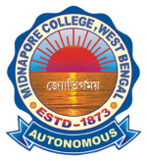

**Project**

**E-Waste Management**

**System**

Submitted by:-

**Sribas das mahapatra, Roll – 2513**

**Kritish shaw, roll - 2515**

**RIJU PAL, ROLL – 2516**

**RAHUL MOLLA, ROLL – 2560**

Guided by :-

**MRS. ARUNITA DAS, LECTURER,**

**DEPT. OF BCA**

**MIDNAPORE COLLEGE (AUTONOMOUS)**

|  |  |
| --- | --- |
| Table of Content | **Page No.** |
| 1. Abstract……………………………………………………… 2. Introduction…………………………………………………… 3. Literature Survey on Related Works………………………    1. Features……………………………………….........    2. Technology used……………………………………    3. Limitations…………………………………………… 4. Motivation …………………………………………………….. 5. Scope of the Project…………………………………………. 6. Our Objectives ……………………………………………….. 7. Software and Hardware Requirements.…………………… 8. Work Flow Diagram………………………………………….. 9. Working Strategy…………………………………………….. 10. E-R Diagram…………………………………………………. 11. Data Flow Diagram………………………………………….. 12. Data Tables and Attributes…………………………………. 13. Results………………………………………………………… 14. Conclusion……………………………………………………. 15. Limitations…………………………………………………….. 16. Future Scope….……………………………………………… 17. References……………………………………………………. | **5**  **6**  **7**    **16**  **19**  **20**  **23**  **24**  **25**  **26**  **31**  **34**  **43**  **44**  **45**  **46** |

**MIDNAPORE COLLEGE**

**(AUTONOMOUS)**

MIDNAPORE, PASCHIM MEDINIPUR

**CANDIDATE'S DECLARATION**

We hereby certify that the work which is being presented in the thesis entitled “E-WASTE MANAGEMENT SYSTEM” by Sribas Das Mahapatra, Kritish Shaw, Riju pal and Rahul Molla in partial fulfilment of requirements for the award of degree of B.C.A submitted in the Department of BCA at MIDNAPORE COLLEGE (AUTONOMOUS) affiliated to VIDYASAGAR university, is an authentic record of our work carried out during a period from August 2023 to April 2024 under the supervision of MRS. ARUNITA DAS. The matter presented in this project report has not been submitted by our in any other University / Institute for the award of B.C.A Degree.

___________________

Signature of the Students

This is to certify that the above statement made by the candidate is correct to the best of my knowledge.

______________________

Signature of the Project Guide

The B.Sc. Viva –Voce Examination of SRIBAS DAS MAHAPATRA, KRITISH SHAW, RIJU PAL and RAHUL MOLLA has been held on _____________________________and accepted.

________________________ ________________________ ___

Signature of the Project Guide Signature of External Examiner

________________ ______________________

Signature of H.O.D. Signature of the Examiners

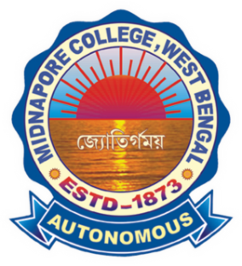

**MIDNAPORE COLLEGE**

**(AUTONOMOUS)**

MIDNAPORE, PASCHIM MEDINIPUR

**Date:**

**CERTIFICATE**

This is to certify that the project is titled- “E-WASTE MANAGEMENT SYSTEM”. This project is submitted by Sribas Das Mahapatra (Roll- 2513), Kritish Shaw (Roll- 2515), Riju Pal (Roll- 2516), Rahul Molla (Roll – 2560) students of Midnapore College (Autonomous) in fulfilment of the requirements for the award of **Bachelor of Computer Application** and submitted to thedepartment of **BCA** of **Midnapore College (Autonomous)**.

This project is an authentic work done by us under the supervision and guidance of Mrs. Arunita Das, Lecturer, Department of BCA, Midnapore College (Autonomous).

The project has not been submitted to any other institution by us for the award of any other degree elsewhere.

*Students:*

Sribas Das Mahapatra (Roll- 2513)

Kritish Shaw (Roll- 2515)

Riju Pal (Roll- 2516)

Rahul Molla (Roll – 2560)

--------------------------------------------------- ------------------------------------------------------

(Signature of the Project Guider) (Signature of the HOD)

Mrs. Arunita Das Dr. Krishna Gopal Dhal

Lecturer, Dept. of BCA Head, Department of BCA

Midnapore College (Autonomous) Midnapore College (Autonomous)

**ACKNOWLEDGEMENT**

I would like to express my deepest gratitude to our project guide Mrs. Arunita Das, Lecturer, Department of BCA, Midnapore College (Autonomous), Medinipur, West Bengal for contributing their valuable time and efforts in helping us out with this project. Their expertise, contribution, suggestions and feedback have helped us a lot in improving the quality of the project.

I express my sincere gratitude to Dr. Krishna Gopal Dhal, HOD, Department of BCA, Midnapore College (Autonomous), Medinipur, West Bengal for his stimulating guidance, continuous encouragement and supervision throughout the course of present work.

  I am also grateful to my group members who worked with me, sharing their knowledge and skills.

I would also like to thank my friends for their help, motivation and support.

______________________

Signature of Students

***Name of the students with Roll No.***

Sribas Das Mahapatra (Roll No. 2513)

Kritish Shaw (Roll No. 2515)

Riju Pal (Roll No. 2516)

Rahul Molla (Roll No. 2560)

**ABSTRACT**

The E-Waste Management System project is a comprehensive solution designed to facilitate the efficient management of E-waste through an online platform.

This project aims to streamline processes, enhance accessibility, and improve user experience for administrators, users. The project encompasses various modules that cater to different aspects of E-waste management. This website includes user’s registration, log in, sharing of waste images, waste pick up date, awareness blog regarding environment protection etc.

The website offers user-friendly interface with separate login portals for administrators and users, ensuring appropriate access to relevant functionalities. Administration can manage waste pick up schedules, monitor enrollment, wastes images and oversee the entire process. Common users can register for e-waste donation, access entire webpage, view status, and receive notification.

This project brings several benefits to the common people and its stakeholders. It eliminates manual processes of waste collection, reducing administrative workload and minimizing errors.

The system is developed by using HTML, JavaScript, CSS, Asp.net, and MS SQL Server as a database system to manage and store the data.

Overall, the project serves as a powerful tool to streamline E-waste management, it is a more efficient and user-centric environment.

**INTRODUCTION**

The present ere is the era of using various electronic products and semiconductors. We cannot spend a day without using electronics devices. That’s why the e-waste is increasing day by day.

E-waste means electrical and electronic equipment, whole or in part discarded as waste by the consumer or bulk consumer as well as rejects from manufacturing, refurbishment and repair processes. And this waste is a dangerous threat for our nation. Therefore, we need to manage and recycle this waste properly.

So, presenting you to one of the easiest and most efficient way of e-Waste Management System.

It is an Android based application for helping the **Municipality** or **Panchayet Authorities or any Business Personal** to collect e-Waste like used mobile phones, TV, old computer parts, old electronic devices from the common people to recycle these. It is an Web Based Mobile/Desktop application that can be operated by the administrations / authorities to keep records of e-Waste and manage these on daily basis. Our application functions on both side (i.e. client side and user side). First of all, both parties need to install the application and one on the client side must enable their GPS system, based on distance of him/her house, he will get the notification of e-Waste collection date.

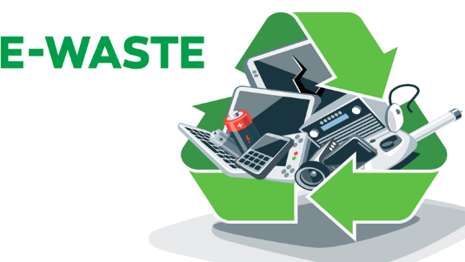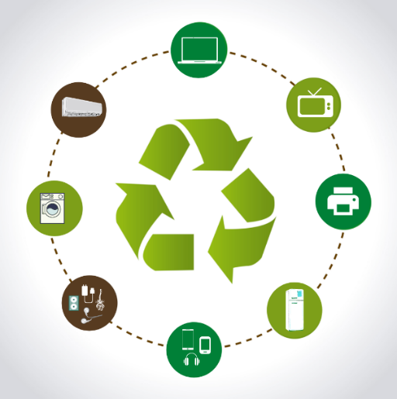

**LITERATURE SURVEY ON RELATED WORKS**

* **[1] Praan Vaayu e-waste management**

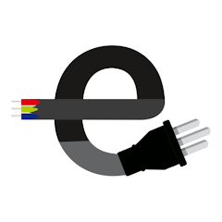 **(Author – Arth Technology - India):**

It is a non-profit organization and collects waste from school, colleges & institutions. It has tie-ups with a recycling unit – Certified by the Pollution Control Board. They have units in Goa, Gujarat & Rajasthan.

* **Features:**

1. User Sign in page has OTP verified mobile no authentication process.
2. In Home page, there are Events, Collection request & Media buttons
3. There are various educational videos related to e-waste in Home page.
4. For New collection Request, people have to fill a form manually.
5. There is also a Collection Request History Checking Page.

* **Technology Used:**

1. Android Studio
2. Kotlin
3. Xml

* **Limitations:**

1. OTP verification process is not working.
2. There is no Location Tracking mechanism.
3. They collect only two types of e-Waste (Mobiles & Computers)
4. They do not provide any customer support page.

* **[2] UZED – Recycle plastic, e-waste**

**(Author –Rapidue Technologies Pvt. Ltd.):**

It is a commercial waste collection application.

UZED is a convenient, rewarding way to dispose and recycle our unwanted, obsolete household items like plastics, electronics waste etc.

It recycles maximum waste sent by us and also dispose of responsibly what can not be recycled to make us a real environment champion.

It provides a responsible, educative and rewarding way to recycle our waste.

* **Features:**

1. This application provides city selection options after log in.
2. In Home page, there are multiple options like- Give Away, Impact, Reward, Account.
3. There is a category of waste like- RECYCLABLES, MOBILES & COMPUTER, LARGE APPLIANCES, BAGS & TOYS, PLASTIC. Users may choose a category.
4. It provides a subcategory of various waste category.
5. This app provides rewards.
6. One can check one’s reward summary.
7. It gives customer support by call or chat.
8. People can subscribe and participate in brand sponsored takeback programs for extra incentives through this app.

* **Technology Used:**

1. Android Studio
2. Java / Kotlin
3. XML

* **Limitations:**

1. It is not a service base application.
2. It covers only some specific tier – I cities.
3. It does not use google map for location tracking.
4. It has no Door Step Services. Here we have to reach the waste in a certain location/place.

* **[3] i899 Recycling – E-Waste Recycle**

**(Author –Spas Group of Companies):**

i899 Recycling provide online based e-waste recycling, metal scrap recycling, battery scrap recycling etc which is optimized for industries, companies and corporates scrap assets management and disposal.

* **Features:**

a) Users can find nearby e-waste collection centers, recycling facilities, or pickup services.

b) The app can scan product barcodes to provide information on disposal methods for specific electronic devices.

c) Offer tips, articles, and videos on e-waste recycling, promoting awareness and responsible disposal. d) Allow users to create profiles to track their recycling history and earn rewards or incentives.

e) Step-by-step instructions for preparing and packaging e-waste for recycling.

f) Show users the positive impact of their recycling efforts in terms of reduced carbon footprint and resource conservation.

* **Technology Used:**

1. Android Studio
2. Java / Kotlin
3. Xml
4. Firebase Data Base

* **Limitations:**

a) Encouraging users to consistently use the app for e-Waste disposal can be a challenge.

b) Collecting user data for rewards or tracking purposes could raise privacy concerns if not handled properly.

c) Developing and maintaining the app, along with supporting infrastructure, can be resource-intensive.

d) Providing rewards or incentives for recycling can be costly and may not be sustainable in the long run.

e) The app's compatibility with various devices and operating systems might limit its accessibility to some users.

* **[4] BookMyJunk**

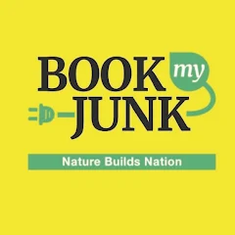**(Author –Reverse Ecommerce):**

Book My Junk is a mobile app developed to assist environment conscious users of electronic devices, when they decide to discard and need someone to come to their doorstep to collect-waste for recycling.

* **Features:**

a) The app allows users to easily book junk removal services with just a few taps on their mobile devices.

b) Book My Junk offers a wide range of junk removal services, including furniture removal, appliance disposal, yard waste removal, and more.

c) The app uses location services to connect users with local junk removal service providers, ensuring quick and efficient service.

d) Users can get instant quotes for their junk removal needs, with transparent pricing based on the type and amount of junk to be removed.

e) The app allows users to schedule junk removal services at their convenience, with options for sameday or future bookings.

f) Book My Junk provides secure payment options within the app, allowing users to pay for their services hassle free.

g) Users can access customer reviews and ratings for junk removal service providers, helping them make informed decisions when booking.

h) The app sends notifications to users regarding their booking status, reminders, and updates on the junk removal process.

i) Customer Support: Book My Junk offers customer support through the app, allowing users to get assistance or resolve any issues they may encounter during the booking process.

j) User-Friendly Interface: The app features a user friendly interface, making it easy for users to navigate through the different features and book their junk removal services efficiently.

* **Technology Used:**

1. Android Studio
2. Java / Kotlin
3. XML
4. Firebase Data Base

* **Limitations:**

a) The app may only be available in certain regions or cities, limiting its accessibility for users outside of those areas.

b) The app relies on the availability and reliability of local junk removal service providers. If there is a shortage of providers or if they do not meet expectations, it can negatively impact the user experience.

c) While the app offers a wide range of junk removal services, there may still be certain specialized or unique types of junk removal that are not covered by the app.

d) The app may not provide options for customized or specific requests, such as specific time windows for junk removal or additional services beyond the standard offerings.

e) While the app provides instant quotes, the pricing may not always accurately reflect the final cost, as it may not account for certain factors such as difficult access to the junk or additional fees for specific items.

f) The app requires a stable internet connection to function properly, which can be a limitation in areas with poor connectivity or during times of network outages.

g) The app may not always reflect real-time availability of junk removal service providers, leading to potential delays or difficulties in booking desired services.

h) Like any mobile app, Book My Junk may experience technical glitches or bugs that can impact the user experience or functionality of the app.

i) Users may have concerns about the privacy and security of their personal information and payment details when using the app.

* **[5] Zolopik E-Waste Recycling**

**(Author – Zolopik E-Waste Recycling Trivendent Technologies Pvt. Ltd.):**

Zolopik.com is the fastest growing company in the online Recycling space. They facilitate scrap material to government authorized recyclers at the best price by following all the compliance of state pollution control board and central pollution control board. From large corporations and SMEs to Households and schools, they help businesses and the community dispose of their old electronics safely, securely, ethically, and in an environmentally sound manner.

* **Features:**

1. This is a web application
2. It provide a ” Book For Pickup / Get Quote” section for selling e-waste.
3. It covers the mega city, like Delhi, Hyderabad, Bangalore, Pune.
4. It has Home Page, About Us, Cities, Services, Contact Us, FAQs, Blog sections.

* **Technology Used:**

1. HTML5, CSS, JavaScript
2. PHP
3. CDNJS

* **Limitations:**

1. There is no sign up page for users.
2. This website is not dynamic.
3. Here, users can only book the date of selling using only email id.
4. There is no proper category wise section of e-wastes.

* **[6] Earth E-Waste Management Private Limited**

**(Author – Mr. Vinkesh Patel):**

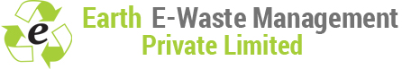Earth E-Waste Management Pvt. Ltd. is one of the premier service provider engaged in offering services for collection, handling, safe management and recycling of electrical & electronic waste (e-waste). They work with their valuable clients to establish the best routes for the reduction, recovery and recycling of a range of business or consumer electrical and/or electronic equipment’s. Their processes are well designed to best utilize the resources of redundant or discarded electrical and electronic equipment’s through its reuse by direct refurbishment or by recovery of materials it contains in environmental friendly way.

* **Features:**

1. This is a web application
2. In this digital world, data are stored on digital media like hard disk, pen drive and similar storage devices. Such data will have confidential and sensitive information. We understand importance of matter and make sure that data will be erased out properly.
3. They apply best possible means to ensure that sensitive data for both organization and individual will be destroyed from storage media.
4. It provides an Inquiry Page for recycling e-wastes.
5. It has Home Page, About Us, About E-Waste, Processes, Services, Contact Us, FAQs sections.

* **Technology Used:**

1. ASP.NET
2. JQuery, JQuery CDN
3. Plesk

* **Limitations:**

1. There is no Sign up/ Log in page for users.
2. This website is not dynamic.
3. Here, users have to book dates every time of e-waste selling.
4. There is no proper category wise section of e-wastes.

* **[7] E-Waste Management**

**(Author – Government of India):**

The website https://eprewastecpcb.in/#/ is an online portal for e-waste management in India. It allows producers, recyclers, refurbishes, and manufacturers of electrical and electronic equipment to apply for registration and authorization under the E-Waste (Management) Rules, 2023. Some of the features and drawbacks of this website are:

* **Features:**

a) It provides a user-friendly interface for online application and submission of documents.

b) It enables faster processing and verification of applications by the Central Pollution Control Board (CPCB).

c) It helps in monitoring and tracking the e-waste collection and recycling targets of the stakeholders.

d) It offers useful information and downloads on e-waste rules, guidelines, and best practices.

e) It supports the implementation of the Extended Producer Responsibility (EPR) policy, which aims to reduce the environmental and health impacts of e-waste.

* **Technology Used:**

1. HTM5, CSS, JavaScript
2. Bootstrap

* **Limitations:**

a) This web site is mainly for business man & e- waste collectors company. Common people cannot use this.

b) It does not have a feedback or grievance redressal mechanism for the applicants and the public.

c) It does not provide any data or statistics on the e-waste generation and management in India.

d) It does not have any interactive features such as chatbots, forums, or quizzes to engage and educate the users.

e) It does not have any social media integration or promotion to increase its visibility and outreach.

f) It does not have any security or privacy certification to ensure the protection of the users' data.

* **[8] E-Waste Management**

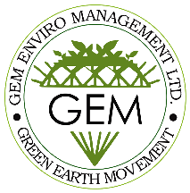**(Author – Government of India):**

The website https://gemrecycling.com is a platform for GEM Enviro Management Limited, a leading waste management agency that provides various sustainability services to its clients. Some of the features and drawbacks of this website are:

* **Features:**

a) The website has a clear and concise introduction of the company's vision, mission, and services on the homepage¹.

b) The website offers detailed information on the different categories of plastic waste and how to calculate the EPR (Extended Producer Responsibility) targets for plastic waste generators².

c) The website showcases the company's clients, videos, and news articles that highlight its achievements and impact in the waste management industry¹⁴.

d) The website has a user-friendly interface and a responsive design that adapts to different screen sizes and devices.

e) The website has a contact form and a chatbot that allow users to communicate with the company and get their queries answered.

* **Technology Used:**

1. WordPress
2. PHP, JavaScript and MySQL
3. jQuery

* **Limitations:**

a) The website does not have a clear navigation menu or a search function that can help users find the information they need easily.

b) The website does not have a blog section or a social media presence that can engage users and provide them with regular updates and insights on the company's activities and the waste management sector.

c) The website does not have a testimonial section or a feedback mechanism that can showcase the company's credibility and customer satisfaction.

d) The website does not have a secure HTTPS connection or a privacy policy that can protect the users' data and online safety.

**MOTIVATION**

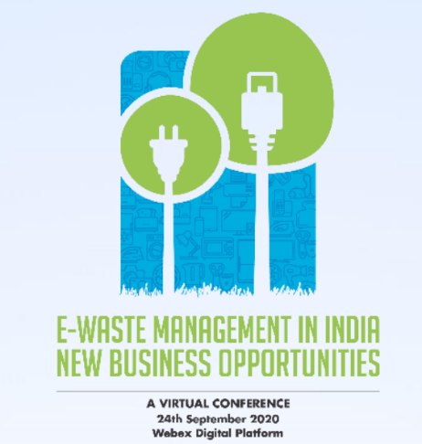 The Confederation of Indian Industry (CII) organized a virtual conference on “E-Waste Management in India: New Business Opportunities” on 24th September 2020 over Webex digital platform. *India ranks fifth amongst the largest e-waste producing countries, after USA, China, Japan & Germany, with over 3.2 MT of e-waste generated in 2019.*

With continuous growth of consumer electronics & appliances year-on-year, India has been witnessing a faster e-waste generation in recent times, which is growing at a Compound Annual Growth Rate (CAGR) of about 30 per cent in the country. *Only 20 per cent of the global e-waste is currently recycled.* This indicates that India has the potential, with the available manpower, infrastructure and by using advanced technologies, to be the E-waste Recycling and Managing hub of the world.

*The total value of all raw materials present in e-waste is estimated at approximately $61.05 billion*, which is more than the GDP of most countries in the world. Since India is highly deficient in precious mineral resources while untreated e-waste goes to landfill, there is need for a well-designed, regulated e-waste recovery regime which would generate jobs as well as wealth.

A United Nations (UN) report on E-Waste, indicates that due to poor extraction techniques, *the total recovery rate of cobalt (the metal which is in great demand for laptop, smart phone and electric car batteries) from e-waste is only 30 per cent.* The report cites that one recycler in China already produces more cobalt (by recycling) than what the country mines in one year. *Recycled metals are also 2 to 10 times more energy-efficient than metals smelted from virgin ore.* The report suggests that lowering the amount of electronics entering the waste stream and improving end-of-life handling are essential for building a more circular economy, where waste is reduced, resources are conserved and are fed back into the supply chain for new products.

Those reasons mention above highly motivated us to make this work.

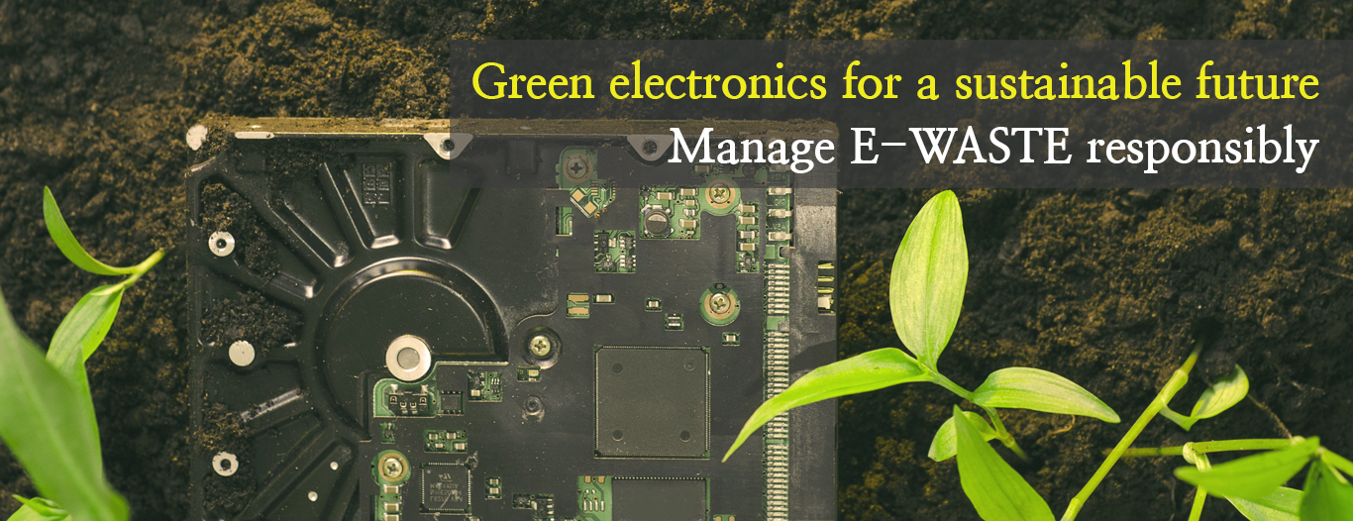

Government of India *“Weste to Health Mission”, “Swacch Bharat Mission”* also inspired us to work on this project. We want a neat and clean healthy environments. We want to bring a big change in India especially in the field of e- waste management for the progress of the country and make our environment healthy for upcoming generations.

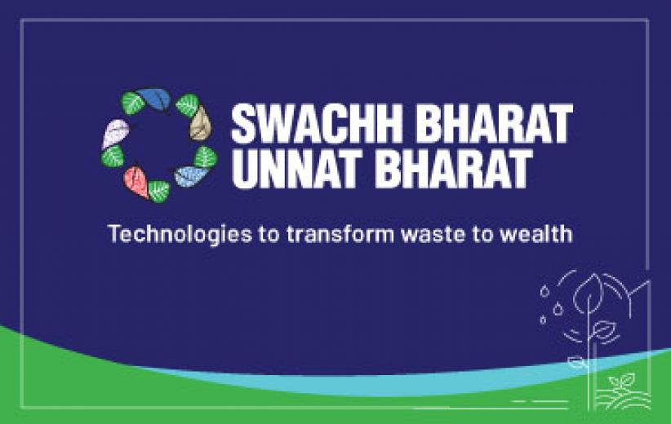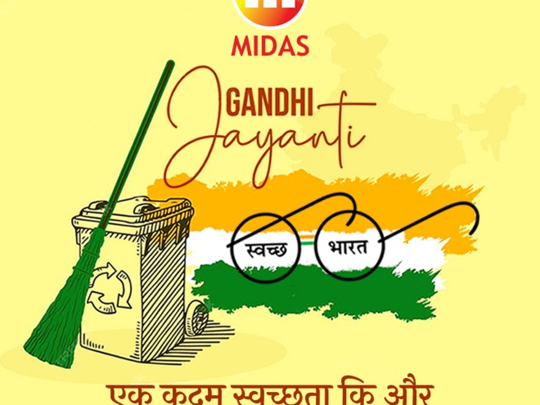

**SCOPE OF THE PROJECT**

*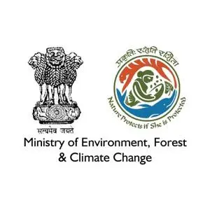On 19th May, 2022, Ministry of Environment, Forest and Climate Chane, Govt. of India published a draft rule, namely E-waste (Management) Rules.*

These rules clearly focus on dismantling, recycling and processing of e-waste or electrical and electronic equipment. These rules come into force from 1st day of April, 2023.

Therefore, various scopes of this project are given below-

1. **Business Scope:** There is a huge amount of business scope on e-waste management and recycling.
2. **Environment Friendly:** It will promote soil fertility and maintain nutrient.
3. **Streamlining Waste Management Operations with Software**: This work provides an opportunity to streamline these operations by digitizing and automating various tasks. This results in improved efficiency, reduced errors, and enhanced coordination among all parties involved.
4. **Improved Efficiency and Cost Savings**: E-waste management software has emerged as a game-changer in the industry, offering substantial improvements in efficiency and also to save money. One key aspect of e-waste management software is its ability to optimize routing and scheduling.
5. **Enhanced Data Management and Reporting:** Waste management software revolutionizes data management and reporting in the industry, providing organizations with powerful tools to track, analyse, and report on waste management activities. By digitizing data collection and leveraging advanced analytics, software solutions enable more accurate and timely reporting, leading to improved decision-making and transparency.

Additionally, waste management software enables real-time data tracking and analysis.

**OUR OBJECTIVES**

Sole objective of our project is to overcome the limitations of existing projects.

We want to create an application which can be used by both, the e-waste givers and e-waste collectors. There is also options of administrator log in, which helps in tracking all the operations

Our main objectives are given below: -

1. The software needs to be installed on both sides, i.e., authority and common people.

2. Our app will provide Google Map API to keep track the location.

3. We mainly focus on collections of e-waste only.

4. We will provide our services in Tier-III cities, Towns and Rural areas.

5. In our app common users gets reward points in exchange of e-waste. He/she can redeem the points into Flipkart’s Gift Vouchers, Electric Bill subsidy Vouchers etc.

6. Municipality can keep track e-waste production reports of every user.

7. Users can schedule e-waste giving date according to their comfort.

8. In our application, people can get articles, videos on e-waste recycling and their impact in environment.

9. Our application provides real time notifications to the users for any Municipal’s or Panchayet’s awareness events regarding environment pollutions, waste management, tree plantations etc.

**SOFTWARE AND HARDWARE REQUIREMENTS**

To implement this project some minimum specific hardware and software are needed. And also, to run the project minimum systems require containing platform is needed.

***Minimum Hardware Requirements (For Developers Only): -***

* **CPU:** - The CPU requirements for this project can vary depending on the specific needs and scale of the project.
  + Processor: Intel Core i5 or equivalent.
  + Speed: - 2.0 GHz or higher.
  + Cores: - Quad-core or higher.
* **RAM:** - The RAM is requiring for this project can vary depending on factors such as the expected user load, complexity of system, and the software and technologies used.
* RAM: 4 GB.
* **GPU:** - The GPU requirements will depend on the complexity of the graphics and visualizations utilized in the project, some GPU are: -
* Intel UHD/Intel iRISXe.
* AMD graphics card.
* **Hard Disk:** - To determine the hard disk requirements for implementing the project, several factors should be considered. Like the size of project, expected data storage needs, and many specific performance considerations.
* 15 GB (Average).
* **Operating System (O.S): -** To implementing this project we need a best O.S of security, and wide support for various web technologies like ASP.NET, MySQL., etc.
  + - Windows-7 or later (64 bit)
    - Linux (64 bit).

***Minimum Software Requirements (For Developers Only): -***

* **Visual Studio 2010 ultimate (IDE for development): -** Visual Studio 2010 Ultimate is an Integrated Development Environment (IDE) designed for software development projects. It provides a comprehensive set of tools and features to support developers in creating various types of applications, including desktop, web, mobile, and cloud-based solutions. A powerful editor with syntax highlighting, code completion, and intelligent code suggestions to enhance productivity.
* **ASP.NET Framework 4:-** ASP.NET Framework 4 is a web development framework provided by Microsoft that allows developers to build dynamic websites, web applications, and web services. It is specifically designed to work with the .NET Framework and provides a rich set of tools, libraries, and components for building robust and scalable web applications.
* **Microsoft SQL Server 2016: -**Microsoft SQL Server 2016 is a relational database management system (RDBMS) developed by Microsoft. It is designed to store, manage, and retrieve data efficiently and securely. For a departmental exam and information management project, Microsoft SQL Server 2016 offers the following features and benefits:

**a) DATA STORAGE AND MANAGEMENT:** SQL Server 2016 PROVIDES a robust and scalable platform for storing and managing data. It supports various data types, including structured, semi-structured, and unstructured data. The database engine offers features like table creation, indexing, data integrity enforcement, and transaction management.

**b) Security:** SQL Server 2016 offers a range of security features to protect data. It includes authentication mechanisms for user login and access control at the database and object levels. Additionally, it provides encryption options to secure data at rest and in transit. SQL Server 2016 also supports auditing and monitoring features for tracking and analysing database activities.

**c) Querying and Data Manipulation:** It allows developers to retrieve, insert, update, and delete data from the database using SQL statements. It supports advanced querying capabilities, including joins, sub queries, aggregate functions, and window functions.

* **Microsoft SQL Server Management Studio 18:-** It provides by Microsoft for managing and administering SQL Server databases. It allows users to create, modify, and delete databases, tables, views, stored procedures, and other database objects. It offers wizards and graphical editors for easy database schema design and modification. It allows users to configure server settings, manage security permissions, create and manage backups, and monitor database performance. It also includes tools for database index management, and query performance analysis.
* **HTML: -**HTML (Hypertext Markup Language) is a standard markup language used for creating the structure and content of web pages. For a departmental exam and information management project, HTML serves as the foundation for building web-based interfaces and displaying information. It is used for Page Structure, Text Formatting, Forms and User Input, Images and Multimedia, Hyperlinks.
* **CSS:-** CSS (Cascading Style Sheets) is a styling language used to define the appearance and layout of HTML elements on a web page. In a departmental exam and information management project, CSS plays a crucial role in enhancing the visual presentation and user experience. It is used for Box Model, colours and Backgrounds, Layout and positioning, etc.
* **JavaScript: -** JavaScript is a powerful programming language that adds interactivity and dynamic functionality to web pages. In a departmental exam and information management project, JavaScript can be used to enhance user experience, perform client-side data processing, and enable interaction with the web page. It is used for Event Handlin, Form Validation, Dynamic Content Manipulation, Data Manipulation and processing, etc.
* **C sharp (C#):** -It is a versatile programming language developed by Microsoft. It is widely used in the development of various types of applications, including departmental exam and information management projects. Here's how C# can be utilized in our project: Back-end Development, Object-Oriented Programming (OOP), Database Integration, Web Development, etc.

 **WORK FLOW DIAGRAM**

**WORKING STRATEGY**

**Step by step procedure to donate E-waste by user in online:-**

1. User must have to register himself/herself in the website.
2. User make sure they login the system.
3. Then user see some options in his dashboard and he fill the form by providing some basic details and can upload E-waste images.
4. After verification by Admin user get a notification via email or phone of confirmation.
5. Or he/she can also check his status in website.
6. Next after the agent will pick up the waste from his home.

**How to educate people about harmful effects of E- waste**:-

1. In our website there is an important link section.
2. Here we will provide the Govt. of India and Govt. of WB official website, all environment related Govt. scheme, etc.
3. There is also an FAQ section, where some commonly asked queries are written.

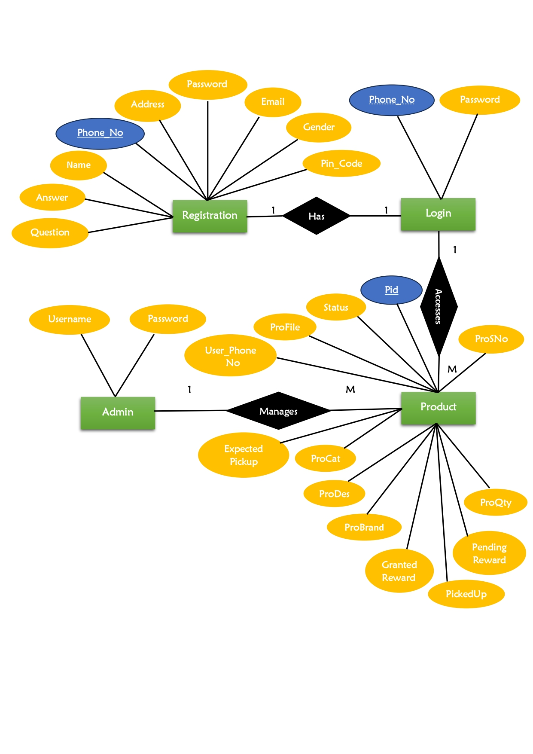 **E-R DIAGRAM**

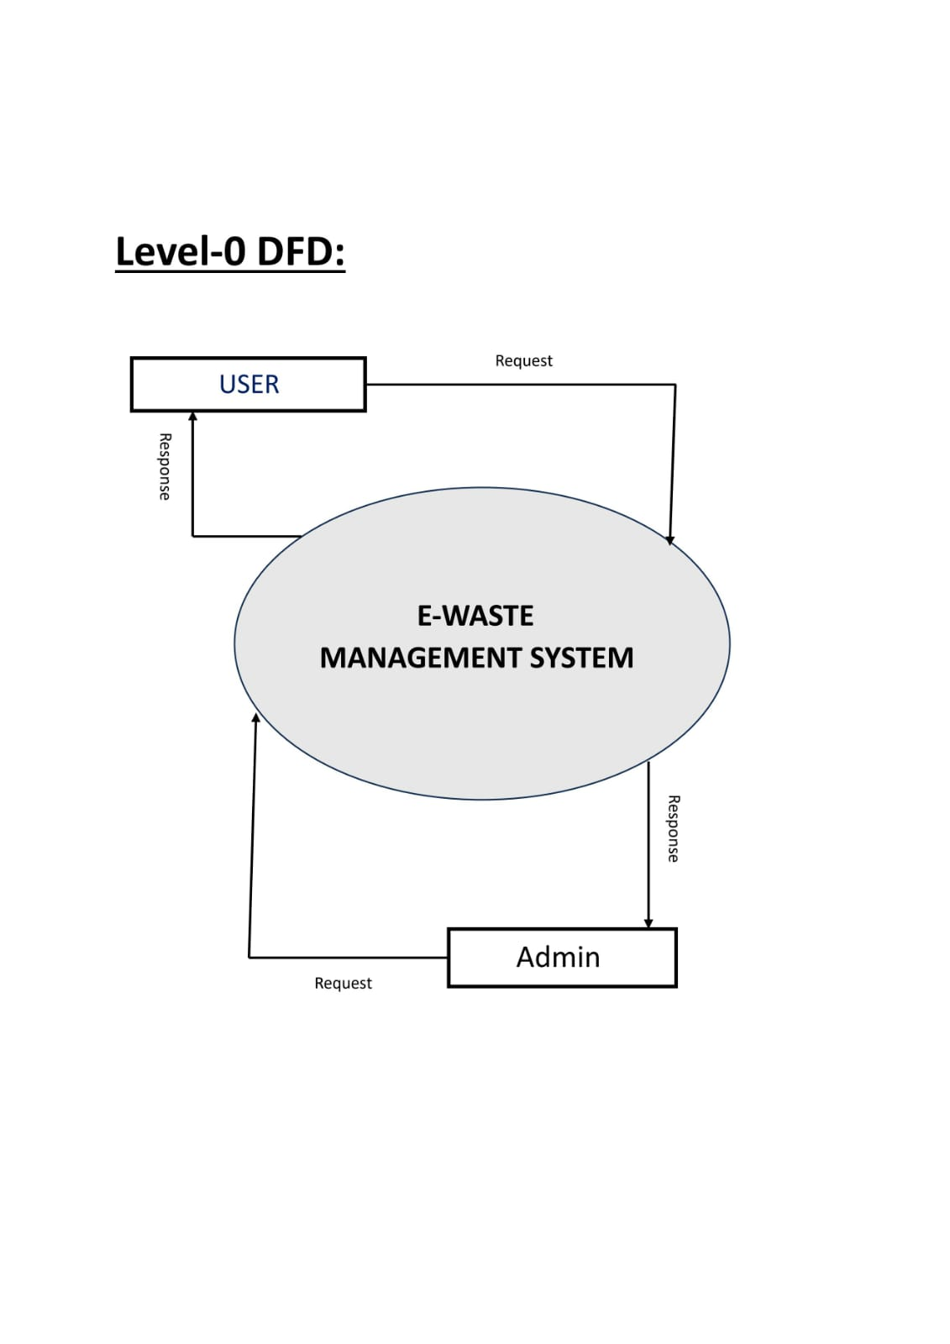 **DATA FLOW DIAGRAM**

0.0

**USER VIEW**



**ADMIN VIEW**



**DATA TABLES AND ATTRIBUTES**

**Table:- Security Questions**

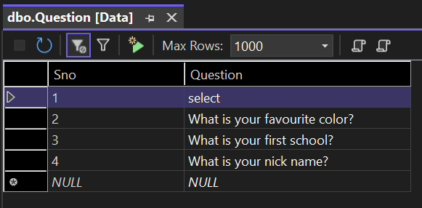

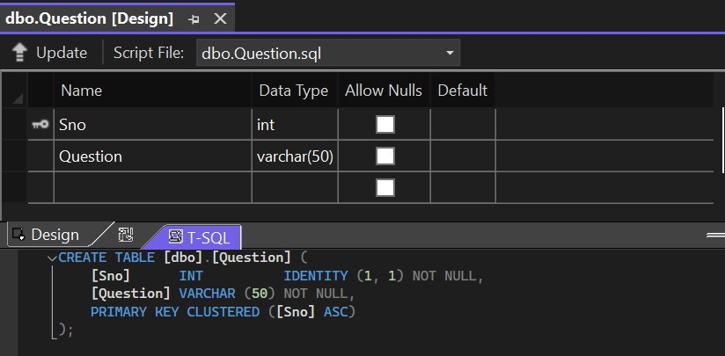

**Table:- Registration**

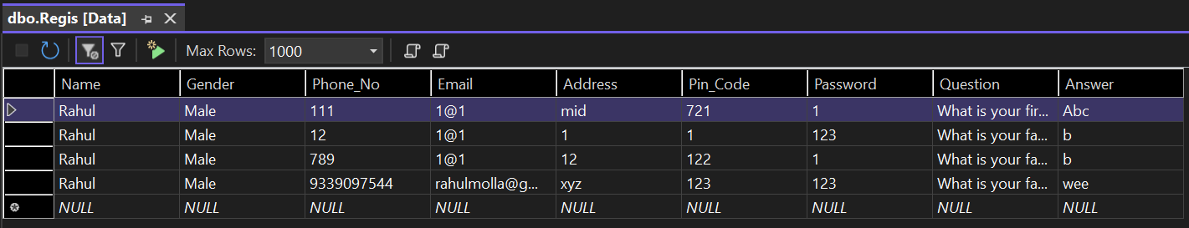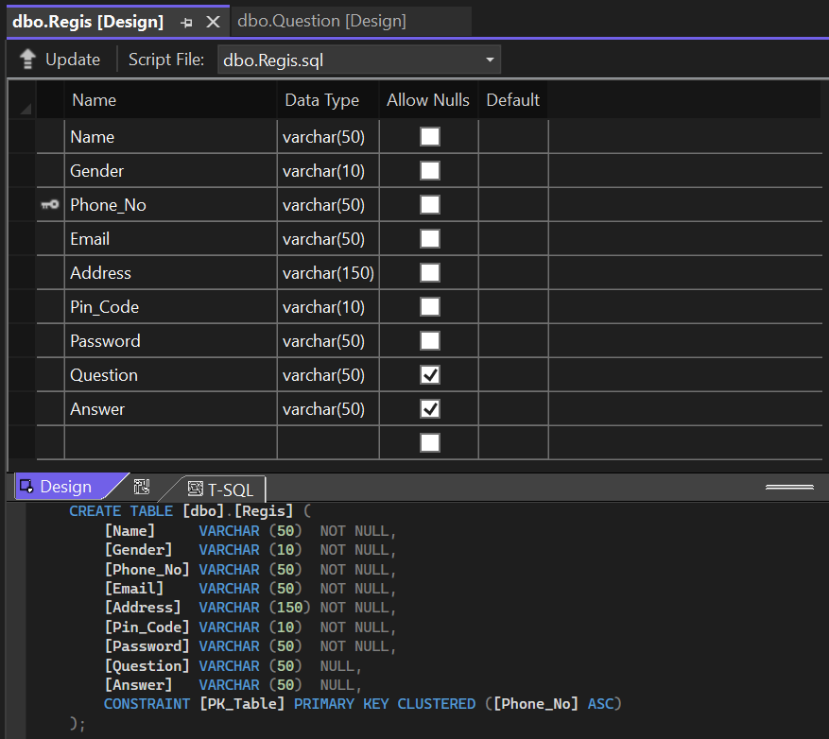

**Table:- Product Details**

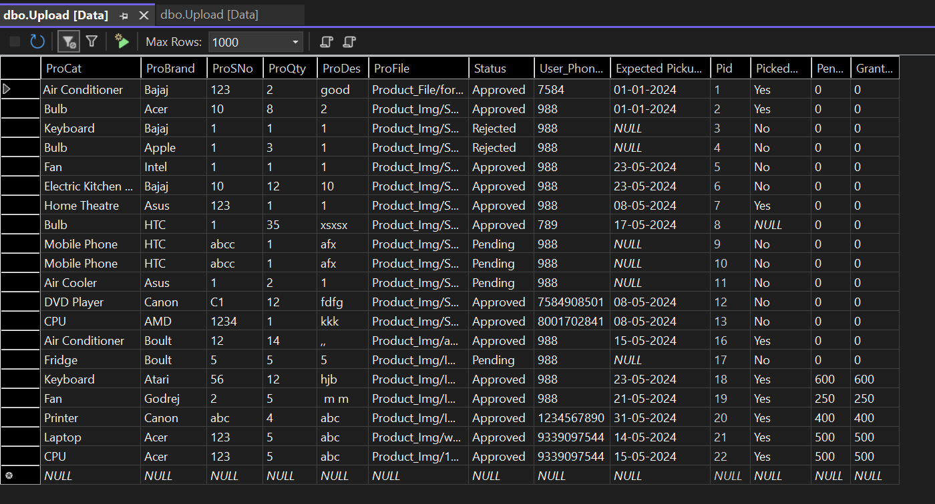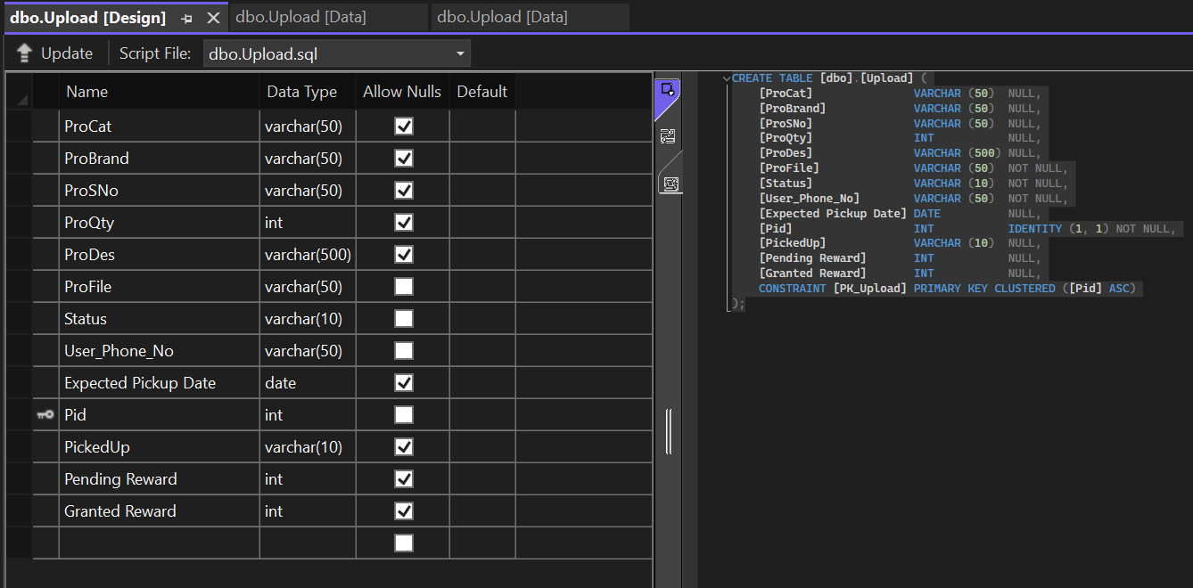

**RESULT**

**(SNAPSHOTS OF WEB APPLICATION)**

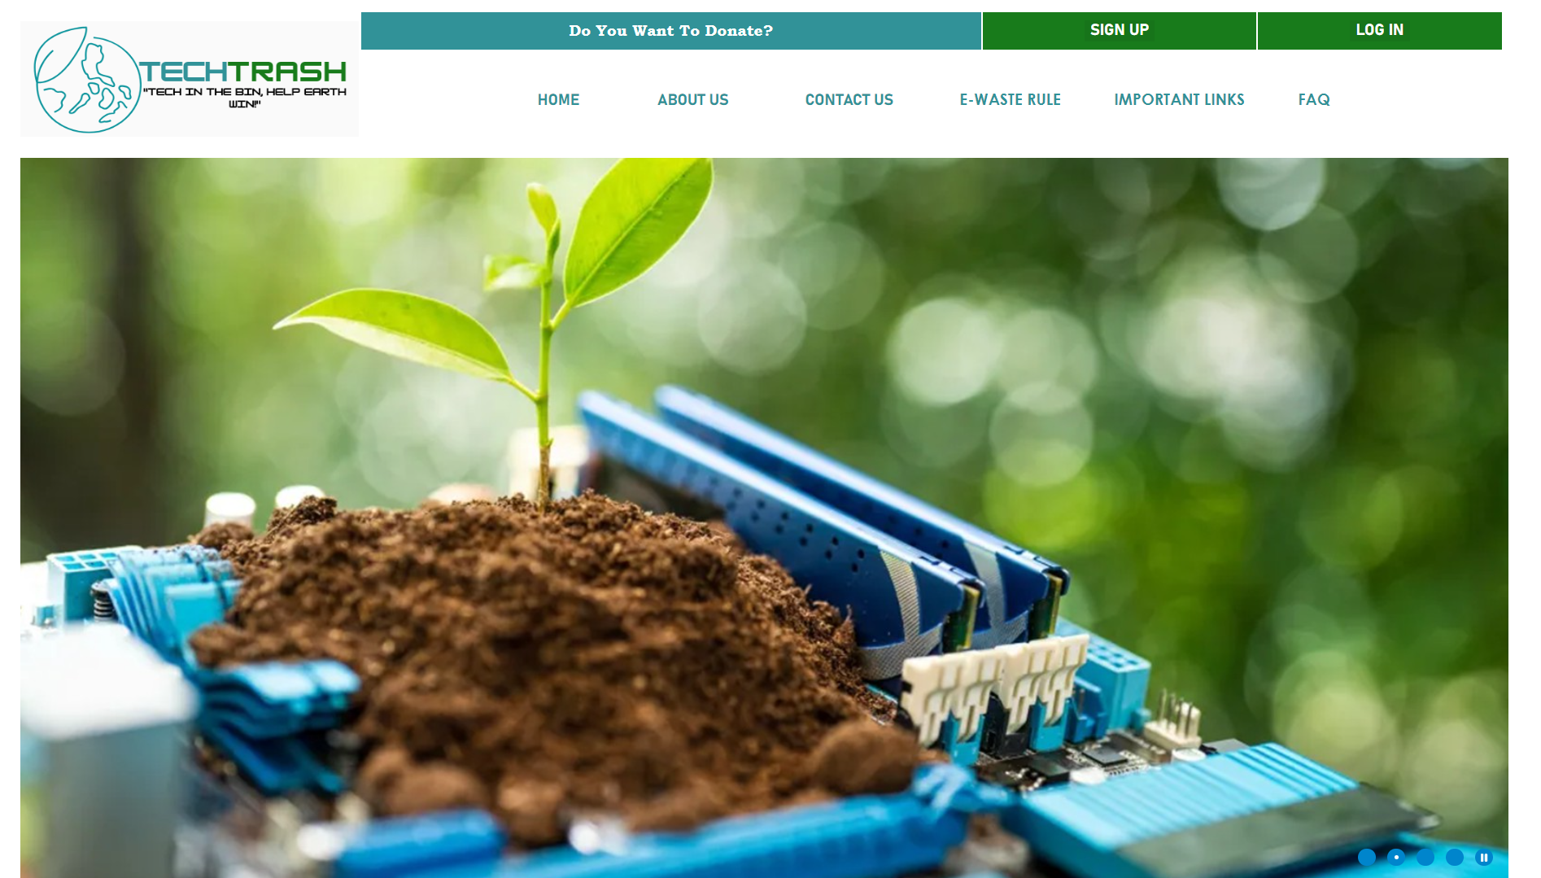**Home Page of this Application:-**

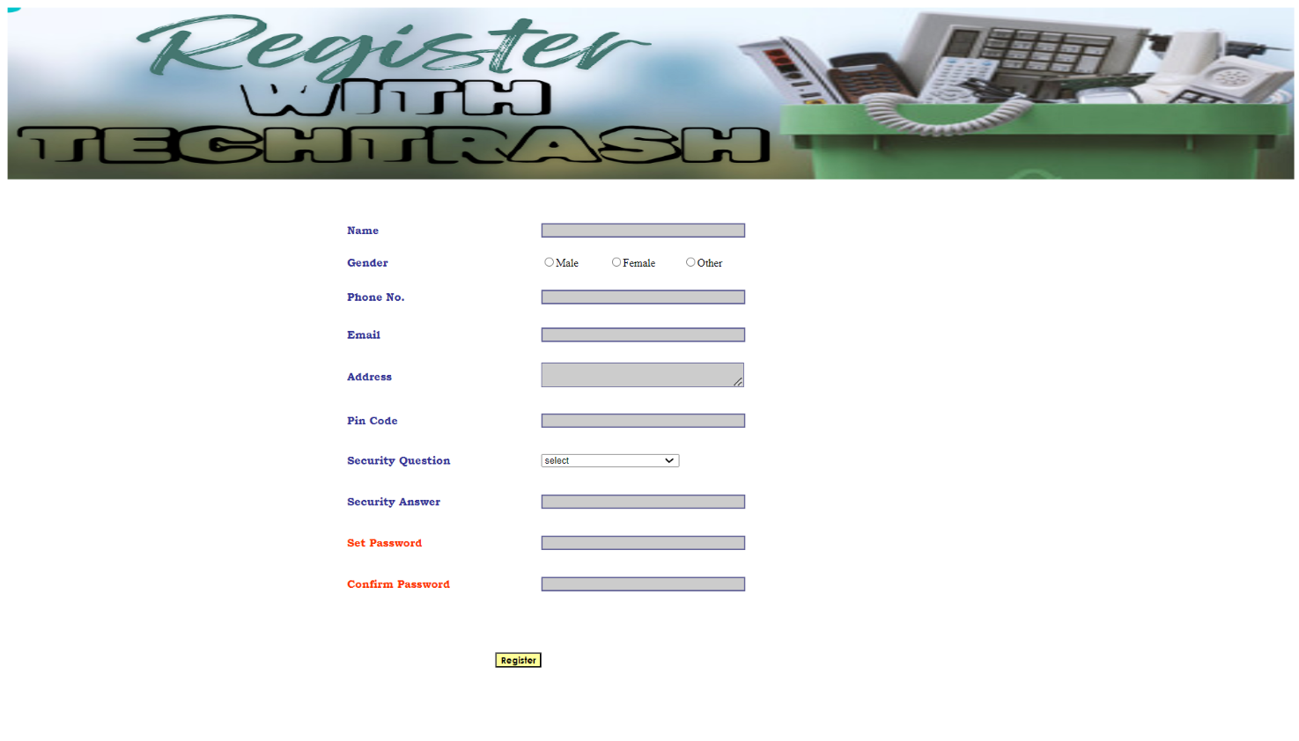**User/Donor Registration Page:-**

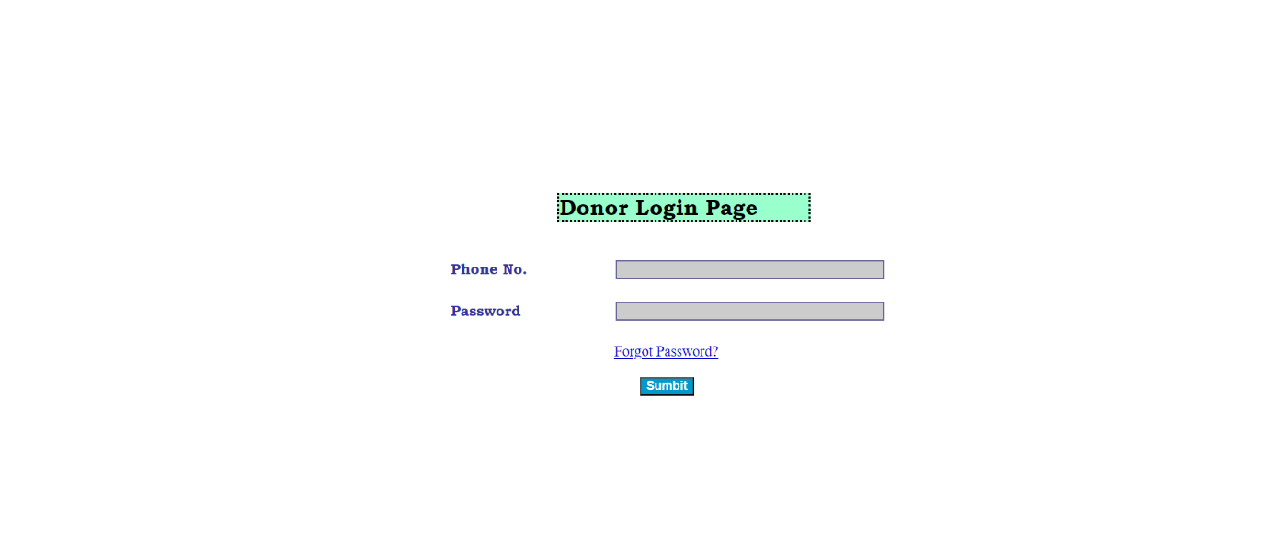**User/Donor Login Page:-**

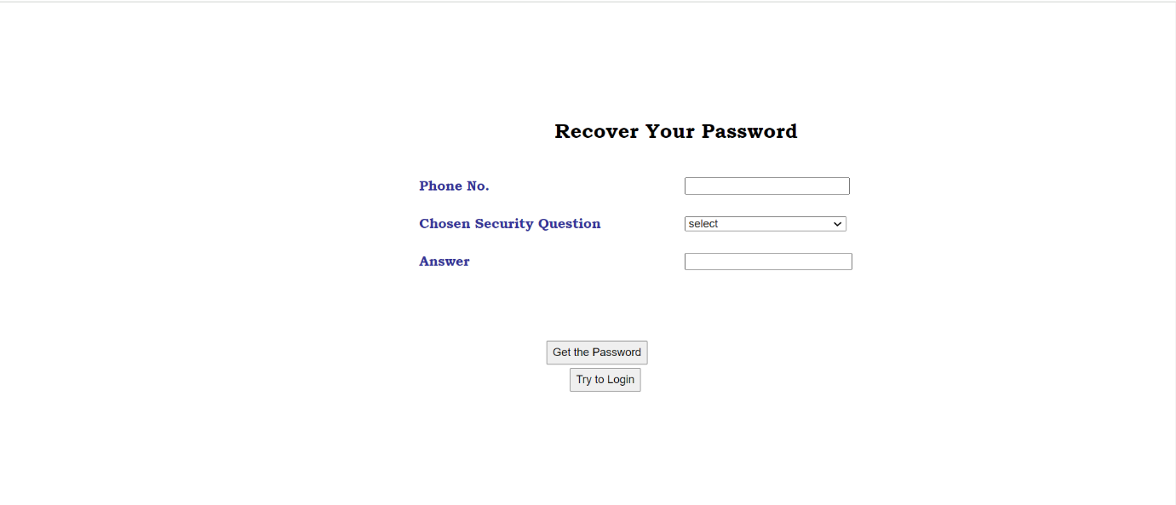**Forgot/Recover Password Page:-**

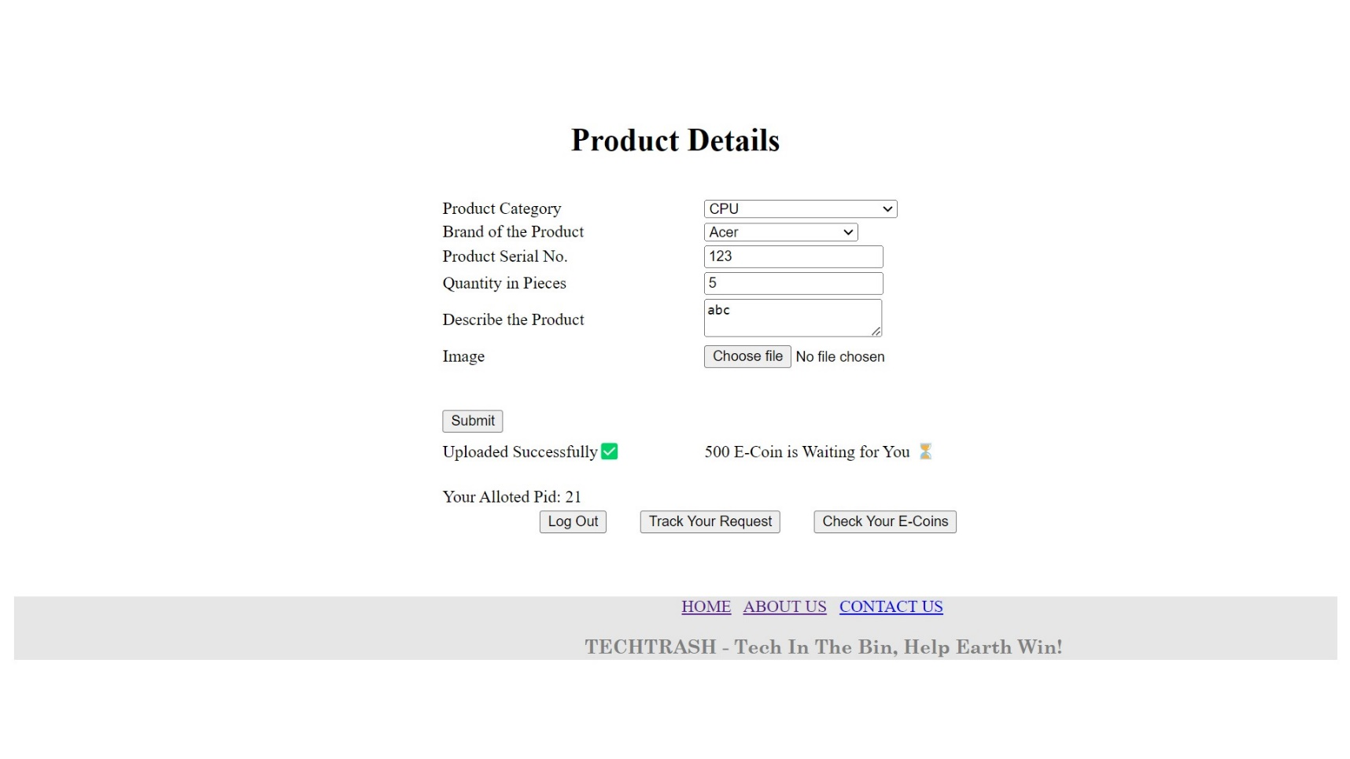**E-Waste Details Page:-**

**Product Status Page:-**

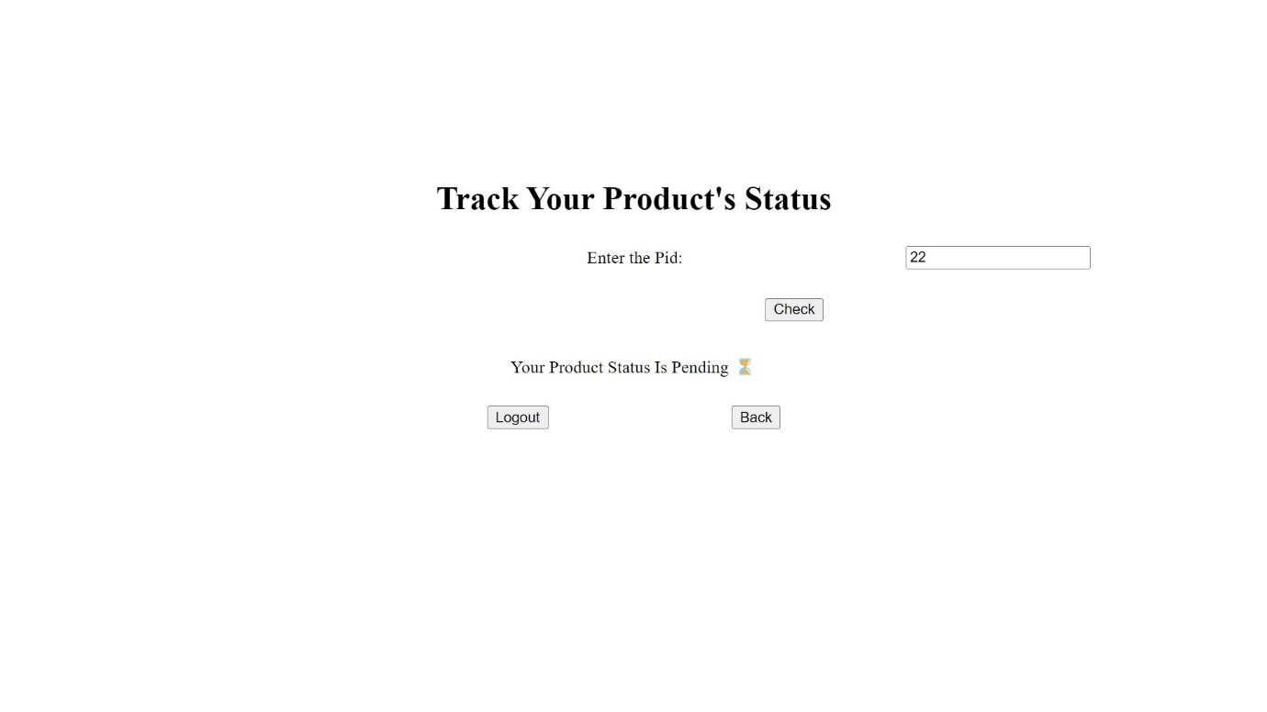

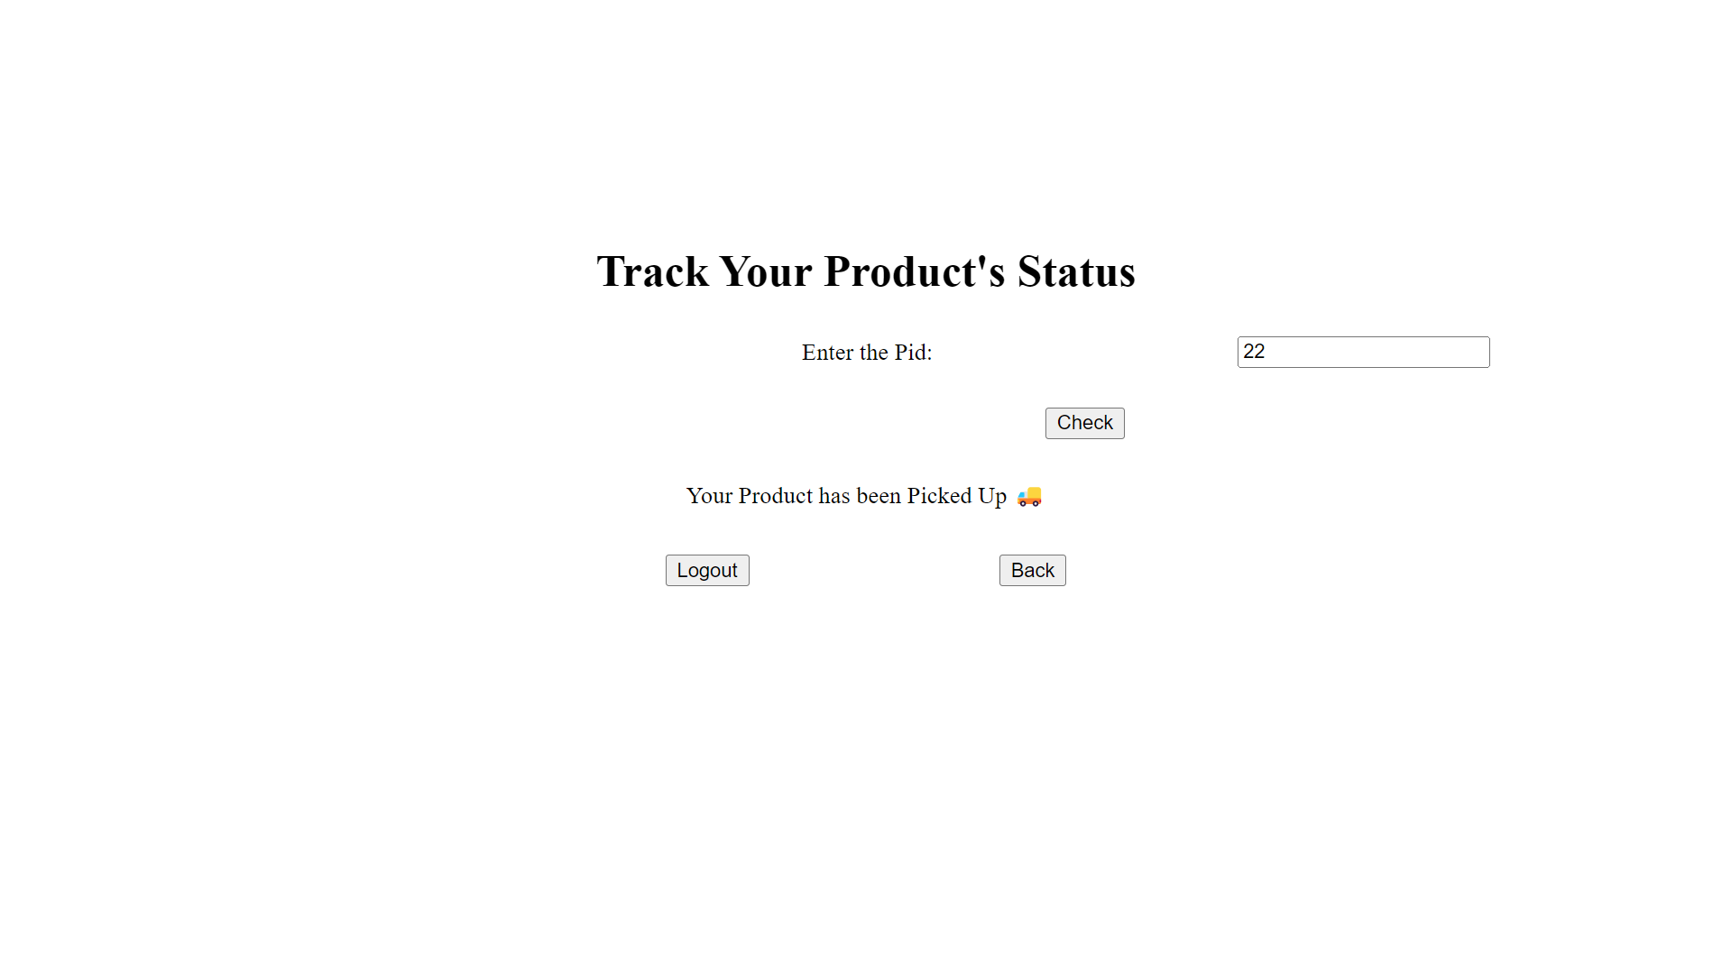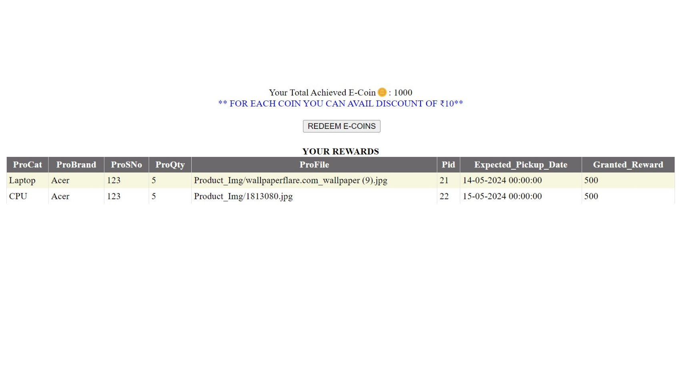**Rewards Points:-**

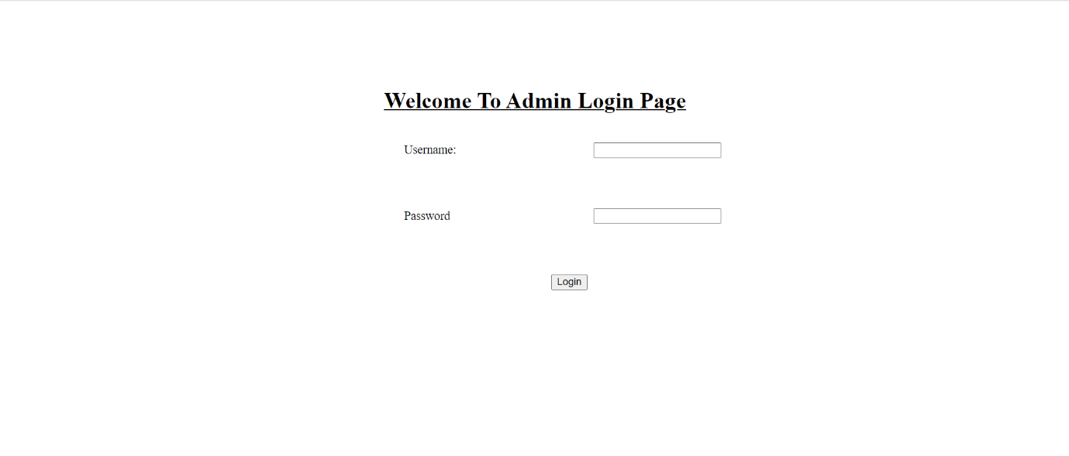**Admin Login Page:-**

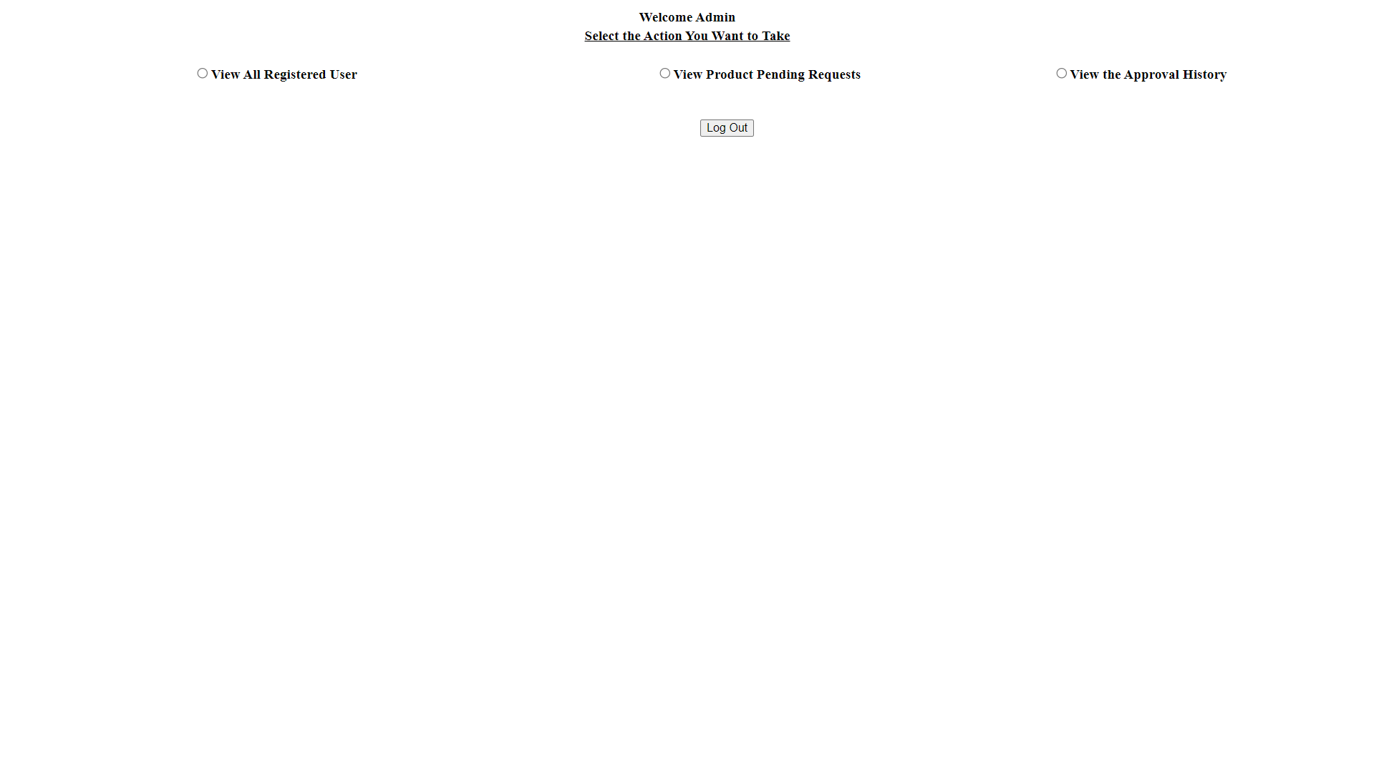**Admin Panel/ Dashboard:-**

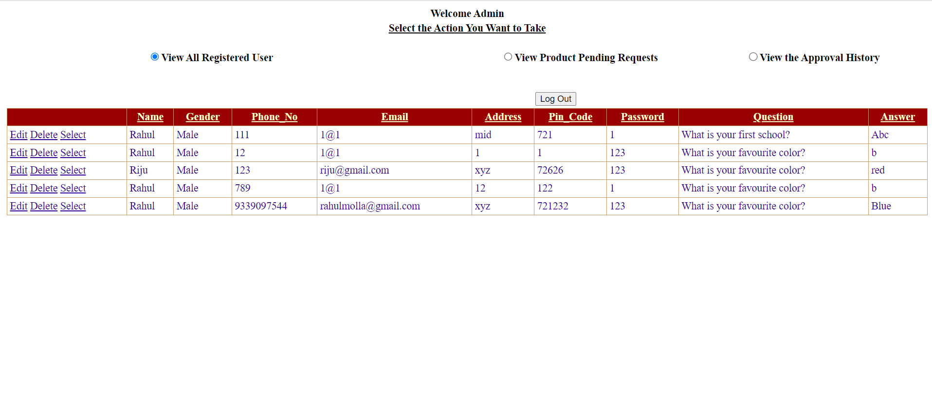**All Registered Users Details:-**

**Pending Request details:-**

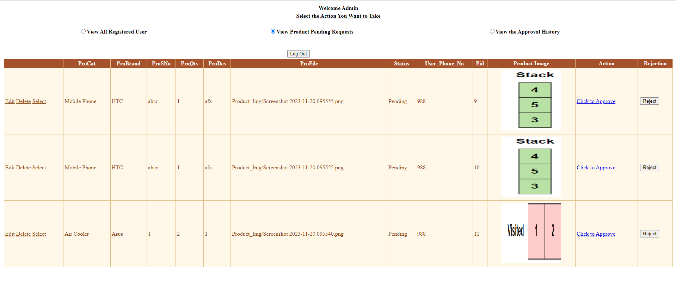

**Approved Product Dashboard:-**

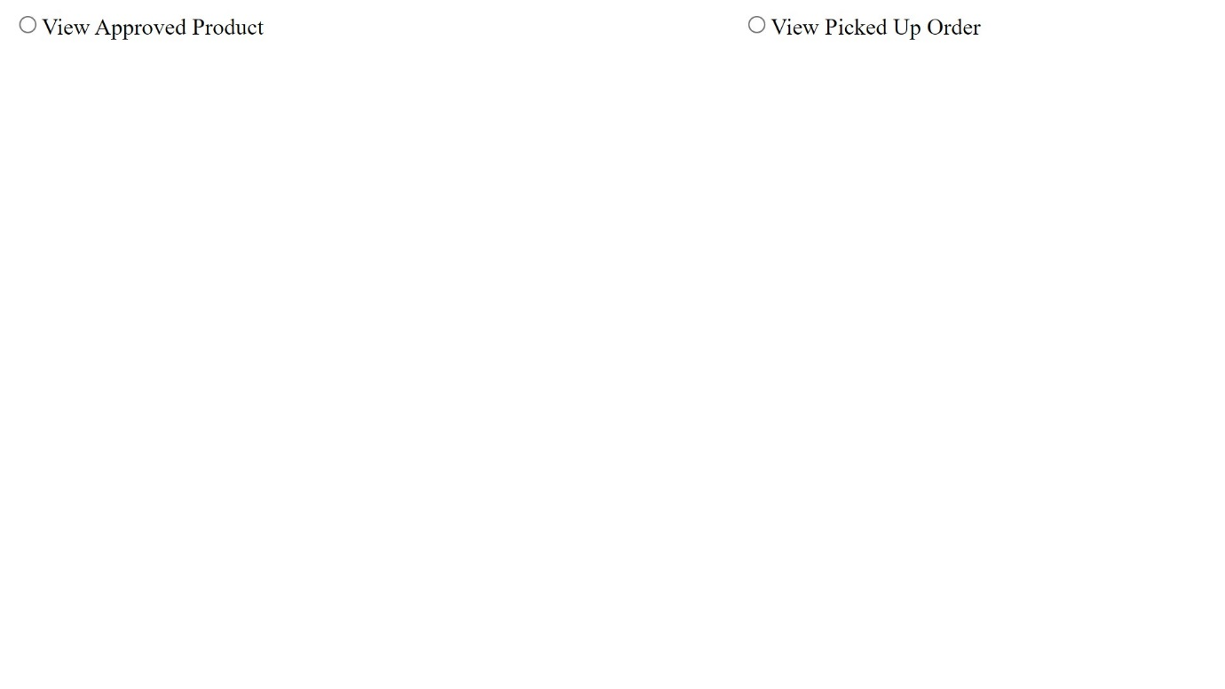

**Approved Product:-**

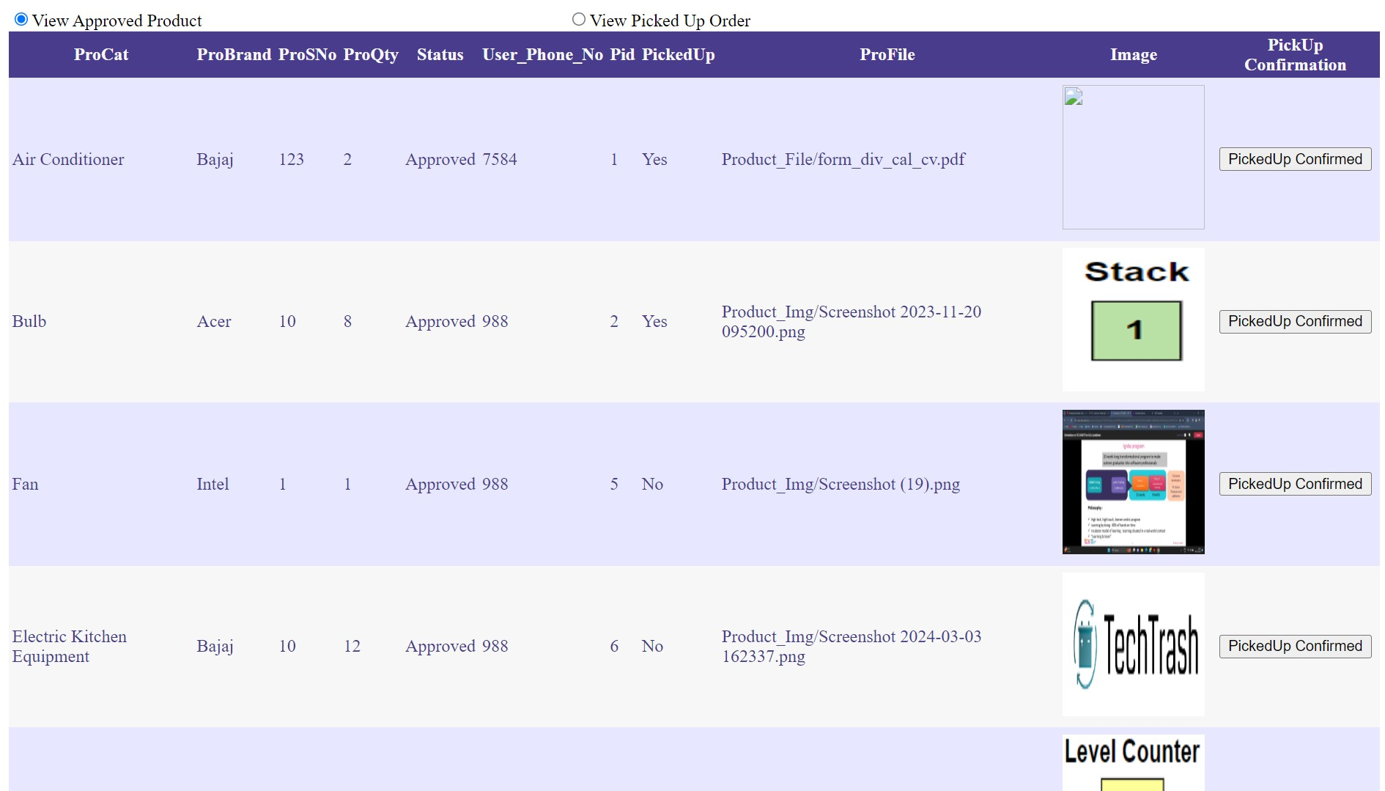

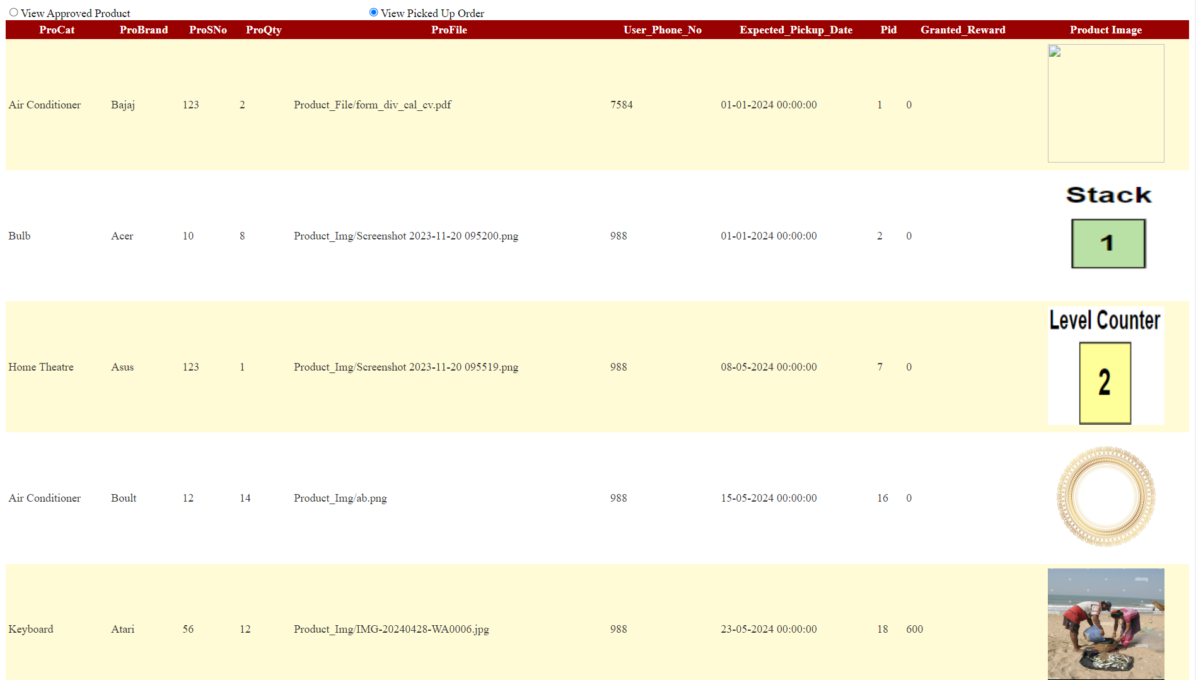**Pick Up History:-**

**CONCLUSION**

After analysing and surveying some of the popular pre – existing E-Waste Management System projects in the market, we have come to the conclusion that there are some limitations to those projects which can further be solved by different approach. In reality, there are very little software application regarding e-waste management.

So, we have come with several ideas to tackle the problems with more optimized methods that are to be implemented in the project. The ‘E-Waste Management System’ application is truly a new thing technically as well as conceptually with tremendous potential to decentralize and transform the manner in which we conduct activity. In today's era, the world is looking for such applications that use this type of technology, concept & method. And we tend to fulfil these needs with a hope. We are sure that our application is going to bring a radical change in the process of e-waste collection which has been going on for a long time. We believe our application stands out from every other existing methods and holds the potential to grow further and sustain in market.

**LIMITATIONS**

* E-mail or Mobile No. notification is not available.
* Location tracking through Google Map is not available.

**FUTURE SCOPE**

Our main plan to overcome the limitations and implement all possible features in our application. Here, our future working methods are described below-

* We will develop a comprehensive feature list for the e-waste Management System App based on the literature survey and user needs.
* We will try to fulfil our objectives mentioned above through development of this App.
* We will provide a user-friendly and intuitive interface for data entry, e-waste selling and reporting, ensuring that users can easily input information about their e-waste disposal and recycling activities.
* We will implement more features for tracking and monitoring e-waste collection and recycling efforts, providing users with real-time updates on their environmental impact.
* Refine the app based on user feedback and conduct further testing to ensure a seamless user experience.

**REFERENCES**

* [1] Praan Vaayu e-waste management

(Author – Arth Technology - India):

https://play.google.com/store/apps/details?id=com.praanvaayu.ewaste

* [2] UZED – Recycle plastic, e-waste

(Author –Rapidue Technologies Pvt. Ltd.):

https://play.google.com/store/apps/details?id=com.rapidue.uzed

* [3] i899 Recycling – E- waste Recycle

(Author – Spas Group of Companies):

[i899 Recycling- E-waste Recycl - Apps on Google Play](https://play.google.com/store/apps/details?id=app.i899recycling)

* [4] BookMyJunk

(Author –Reverse Ecommerce):

<https://play.google.com/store/apps/details?id=com.bmj.bookmyjunk>

* [5] Government of India official website:

<https://eprewastecpcb.in/#/>

<https://greene.gov.in/>

* [6] EHS and Waste management:

<https://www.imectechnologies.com/2023/10/17/benefits-waste-management/>

* [7] Zolopik E-Waste Recycling:

<https://www.zolopik.com/>

* [8] Earth E-Waste Management Private Limited:

<http://www.eemplindia.com/services.html>

* [9] GEM Enviro:

https://gemrecycling.com/

* [10] Waste Management System GitHub:

https://github.com/topics/waste-management-system